|  |  |
| --- | --- |
| **Use Case ID:** | Zar3a001 |
| **Use Case Name:** | Register |
| **Area:** | Application |
| **Actor:** | User |
| **Description:** | User creates an account |
| **Preconditions:** | * User needs to download the application * User needs an internet access |
| **Post conditions:** | User has successfully created an account |
| **Triggering Event:** | User clicks “Register” button. |
| **Main Flow:** | 1. Open the application 2. User enters his data 3. User submit his data to system 4. The system validates the user data 5. The system send a verification mail to the user |
| **Additional info for steps:** | Step 2: data is name, username, password, email. |
| **Alternative Flow:** | -if user enter non-valid data, an error message should appear to him. |

* **Register**

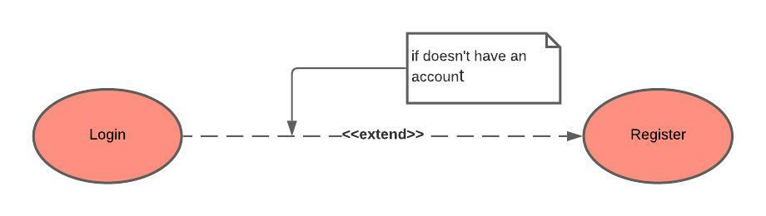

* **Login**

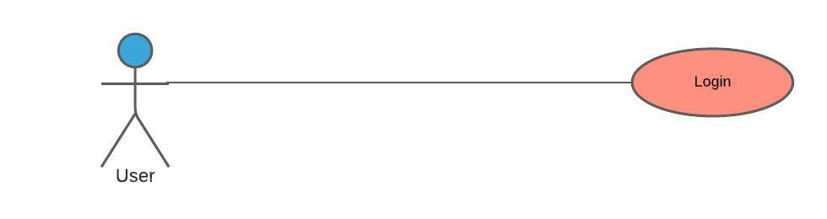

|  |  |
| --- | --- |
| **Use Case ID:** | Zar3a002 |
| **Use Case Name:** | Login |
| **Area:** | Application |
| **Actor:** | User |
| **Description:** | User login to the application using it’s account |
| **Preconditions:** | * User must download the application * User must an internet access * User must have an account |
| **Post conditions:** | * User has successfully logged into the application * The system display the main page of application |
| **Triggering Event:** | User clicks “Login” button. |
| **Main Flow:** | 1. Open the application 2. User enters his data 3. User submit his data to system 4. The system validates the user data |
| **Additional info for steps:** | Step 2: data is username and password. |
| **Alternative Flow:** | -if user enter non-valid data, an error message should appear to him. |

* **Edit interested plants**

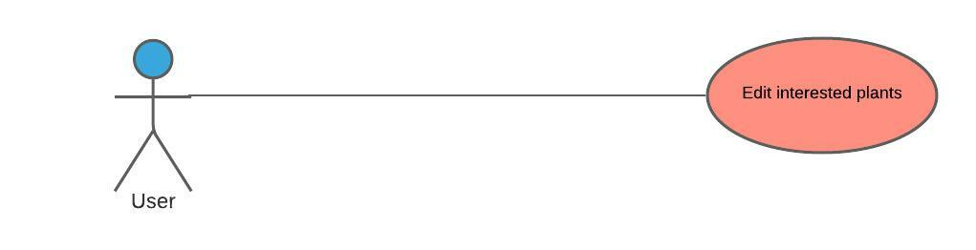

|  |  |
| --- | --- |
| **Use Case ID:** | Zar3a003 |
| **Use Case Name:** | Edit interested plants |
| **Area:** | Application |
| **Actor:** | User |
| **Description:** | User edit the pre-selected interested plants. |
| **Preconditions:** | * User must download the application * User must an internet access * User must have an account * User must login to the application |
| **Post conditions:** | * Application update the selected interested plants to the user. |
| **Triggering Event:** | User click “Update” button. |
| **Main Flow:** | * User login to the application * User select the items * User submit the items * The application validates the items * The system update the selected items |
| **Additional info for steps:** | Step 2, 3, 4, and 5: items are interested plants. |
| **Alternative Flow:** | -if user doesn’t select any item, an error message will be appeared. |

* **Publish a post**

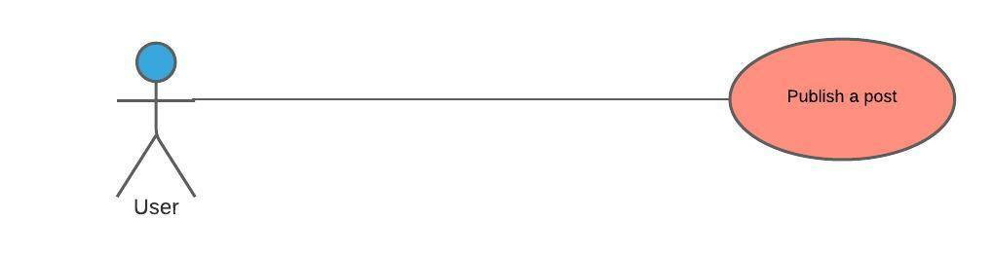

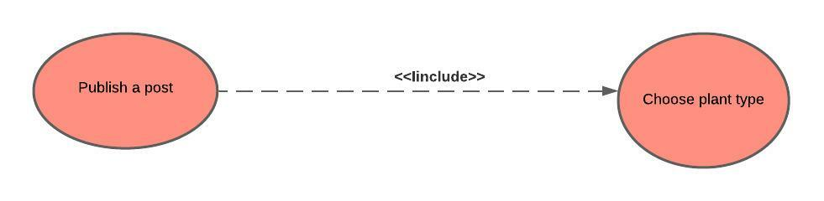

|  |  |
| --- | --- |
| **Use Case ID:** | Zar3a004 |
| **Use Case Name:** | Publish a post |
| **Area:** | Application |
| **Actor:** | User |
| **Description:** | User publish a post in the community area to get help in specific plant. |
| **Preconditions:** | * User must download the application * User must an internet access * User must have an account * User must login to the application |
| **Post conditions:** | Application will make the post available to all users of the application |
| **Triggering Event:** | User click “Post” button. |
| **Main Flow** | 1. User login to the application 2. User choose plant type 3. User submit the post 4. The system validate the post |
| **Alternative Flow:** | -if user doesn’t choose a plant type or doesn’t write any text in the post, an error message will be appeared. |

* **Capture/Upload plant image**

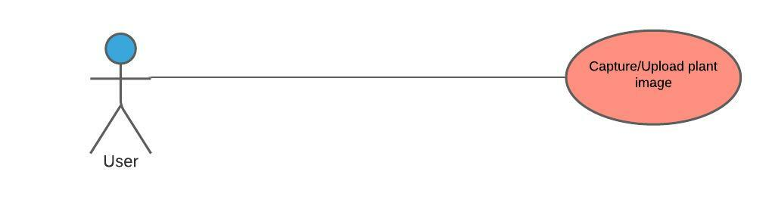

|  |  |
| --- | --- |
| **Use Case ID:** | Zar3a005 |
| **Use Case Name:** | Capture/Upload plant image |
| **Area:** | Application |
| **Actor:** | User |
| **Description:** | User upload or take an image of plant to see if it has a disease or pest. |
| **Preconditions:** | * User must download the application * User must an internet access * User must have an account * User must login to the application |
| **Post conditions:** | The User will have a paragraph shows the result. |
| **Triggering Event:** | User click “Take Photo” button. |
| **Main Flow** | 1. User login to the application 2. User upload or take a photo 3. User submit the photo 4. The system validate the photo 5. The photo is sent to the API. |
| **Alternative Flow:** | -if user doesn’t upload a plant image the application will display an error message. |

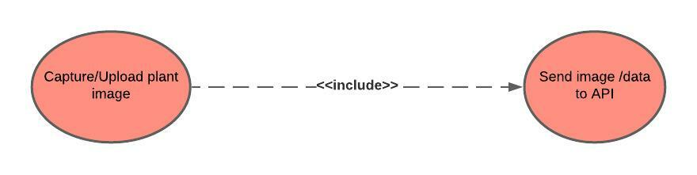

* **Calculate required Fertilizer**

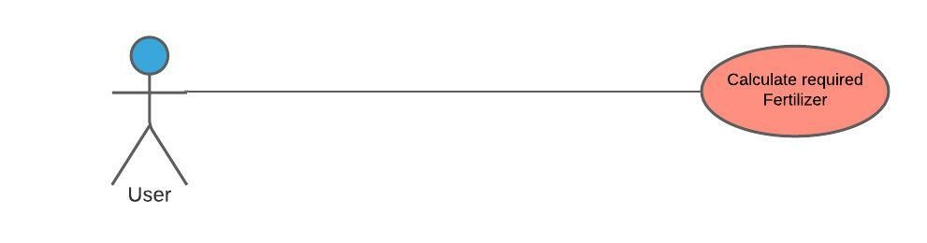

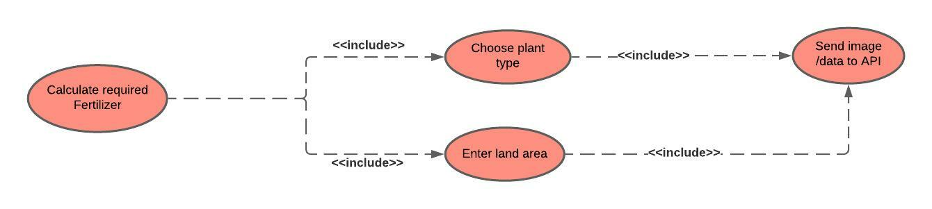

|  |  |
| --- | --- |
| **Use Case ID:** | Zar3a006 |
| **Use Case Name:** | Calculate required Fertilizer |
| **Area:** | Application |
| **Actor:** | User |
| **Description:** | User wants to know the amount of fertilizer suitable to his land area. |
| **Preconditions:** | * User must download the application * User must an internet access * User must have an account * User must login to the application |
| **Post conditions:** | User will have the required amount of fertilizer. |
| **Triggering Event:** | User click “Calculate” button. |
| **Main Flow** | 1. User login to the application 2. User enter data 3. User submit the data 4. The system validate the data 5. The data is sent to the API. |
| **Additional info for steps:** | Step 2, 3, 4, and 5: data is the plant type and the land area. |
| **Alternative Flow:** | -if user enters invalid data, an error message will be appeared. |

* **Manage Profile information:**

|  |  |
| --- | --- |
| **Use Case ID:** | Zar3a007 |
| **Use Case Name:** | User Information |
| **Area:** | Application |
| **Actor:** | User |
| **Description:** | Manage Profile Info |
| **Preconditions:** | * User must have an account on the application * User must be logged into the application successfully. |
| **Post conditions:** | User has successfully logged to his/her account |
| **Triggering Event:** | User clicks “Update profile data” button. |
| **Main Flow:** | 1. Open the application 2. User enters his data 3. User submit his data and photo to the system 4. The system validates the user data |
| **Additional info for steps:** | Step 2: data is name, profile image, password. |
| **Alternative Flow:** | -if user enter non-valid data, an error message should appear to him. Ex: If the user uploads a file in the place designated for uploading a profile photo. |

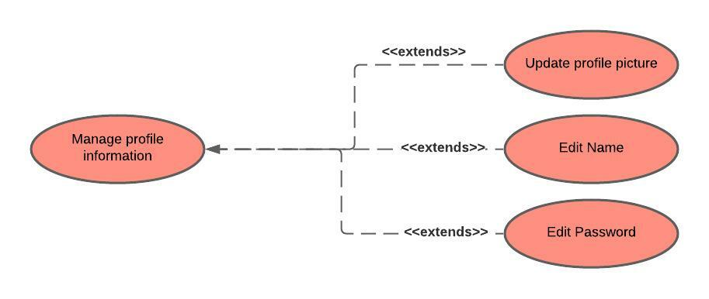

* 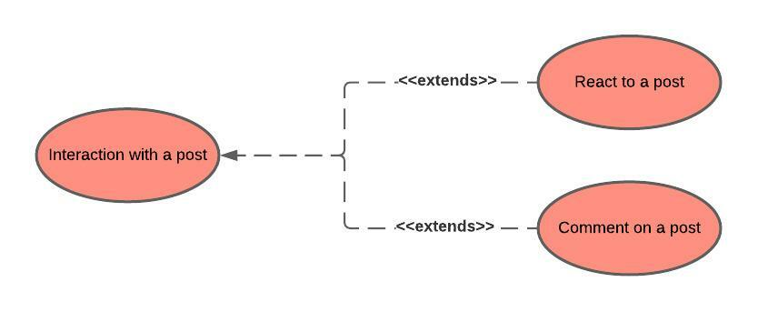**Interaction With a post:**

|  |  |
| --- | --- |
| **Use Case ID:** | Zar3a008 |
| **Use Case Name:** | Posts actions |
| **Area:** | Application |
| **Actor:** | User |
| **Description:** | Interaction with a post |
| **Preconditions:** | * User must have an account on the application * User must be logged into the application successfully. |
| **Post conditions:** | User has successfully logged to his/her account |
| **Triggering Event:** | User clicks “react” icon. |
| **Main Flow:** | 1. Open the application 2. User enters his data 3. User submit his data and photo to the system 4. The system validates the user data |
| **Additional info for steps:** | Step 2: user can react on any post. |